BRAIN-TARGETED TEACHING
LEARNING UNIT

Name: Anna Carello Dates (Allocated Time): 45 minutes over 10 school days
Unit Topic:/Title: Revolution! Grade Level: 5
Content Standard(s): (Not applicable to my school)

Learning Unit Overview:
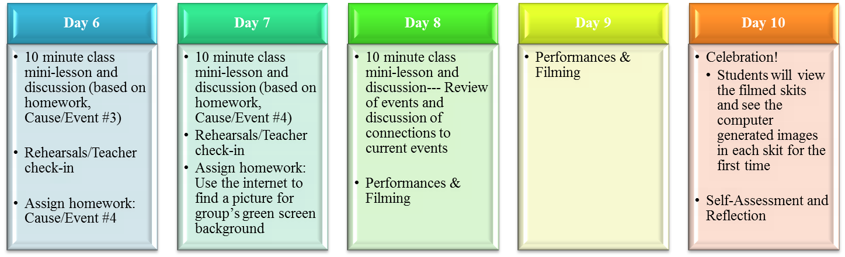

Brain Target #1
Emotional Connection:
In order to establish a purposeful learning climate that is positive, joyful, and promotes a deeper emotional connection to the subject matter, we will:
1. Discuss “Liberty” and “Revolution” and create a class definition of each term to use as a reference point in future class discussions and activities.
2. Play Revolution era music, like Yankee Doodle during class activities.
3. Review and discuss the unit project expectations, schedule, and rubric together to alleviate
any negative fear associated with the novel features of the unit.
4. Allow the students to choose their groups.
5. Give the students a choice in what topic they enact (with final approval from the teacher).
6. Use the television studio as a novel instructional tool (no other class has filmed a skit in
front of the green screen before, so I will convey this “honor” to the students in order to
pique their interest and develop a stronger emotional connection to the project).
7. Give praise and encouraging remarks to each other throughout the entire project.

Brain Target #2
Physical Environment:
In order to promote order and beauty in the classroom, and to encourage active movement amongst the students, the physical learning environment during this unit will be enhanced by:
1. Student created bulletin boards around the classroom. This bulletin board will display anchor charts that the students can refer to at any time during their script
writing or rehearsals.
2. Playing of Revolution era background music as students rehearse their skits.
3. Moving classroom furniture around to accommodate rehearsal space.
4. Clearly displaying the project rubric and schedule so that all students may reference it during their rehearsal time.
5. Maintaining traditional classroom rituals and behavioral expectations.
6. Using the school’s television studio equipped with green screen technology to incorporate novelty and inspire creativity.

Brain Target #3
Concept Map / Advanced Organizer
(feel free to use an online tool):

We will activate prior knowledge and then combine it with new knowledge in order to help students create new patterns of thinking by:
1. Reviewing the previous chapter’s material (the French and Indian War)
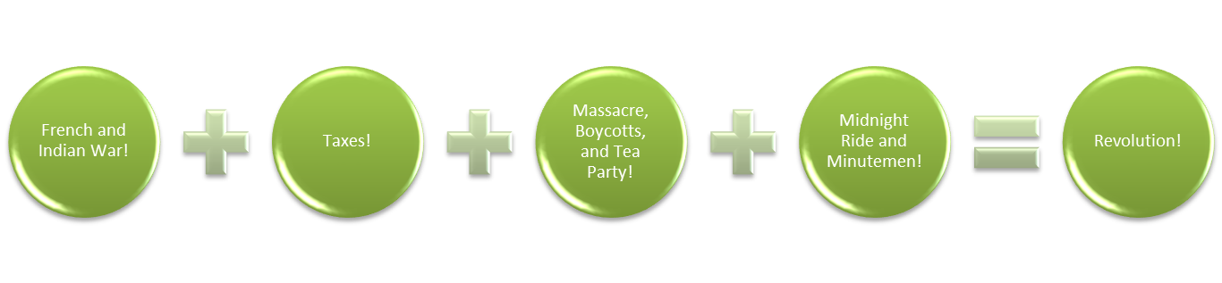
2. Creating a concept map together as a class based on the topics of the next chapter. An example could look as follows:

3. Work in small groups to create a concept map on the topic that they will enact as a group. An example could look as follows:

Learning Goals:
By the end of this unit, students should be able to:
1. Identify the major causes and events leading to the American Revolution
2. Evaluate the significance of each event and its effects
3. Understand the emotional climate in the colonies leading to the Revolution
4. Effectively and safely use the school’s television studio equipment and computer green
screen technology

Brain Target #4
Activities for Teaching Mastery of Declarative/Procedural Knowledge
We will engage in the following activities to master both declarative and procedural knowledge of the unit material. These activities will also encourage long term retention of the subject material:

Objective 1: Identify the major causes and events leading to the American Revolution.
Activities: Students will create and discuss concept maps for each event, first in small
groups and then as a whole class. Students will also have a choice in what cause or
event they would like to enact in a creative skit.

Objective 2: Evaluate the significance of each event and its effects.
Activities: Students will participate in classroom discussions on current events with the same theme in order to create an emotional connection to the content. Students will also consolidate their thinking of each event from the “Big Picture” during each 10 minute “mini-lesson” on days 4-8. Mini-lessons will focus on each event outlined in the concept map created as a class on day 1. Each mini-lesson will include activities like:
A tea sampling (to help students create a memorable experience with English tea)
A paper snowball fight with the class outside (to help students remember how the Boston Massacre began)
An activity when the teacher imposes taxes on the class for essential items like pencils and papers (to help students relate to the feelings on colonists being taxed on items they deemed essential)

Objective 3: Understand the emotional climate in the colonies leading to the Revolution.
Activities: Students will write a script that demonstrates their understanding of the mood of the event based on dialogue and character actions. Teacher will also integrate music from the era while students are rehearsing skits to help stimulate emotional arousal or encourage an emotional connection to the time period. Clips from Liberty Kids (an age appropriate cartoon by PBS) can also be shown to help visually demonstrate the tension in the colonies at the time.

Objective 4: Effectively and safely use the school’s television studio equipment and computer green screen technology.
Activities: Students will tour the television studio before rehearsals begin, review safety protocols, as well as maintain classroom rituals and behavior in the new space. Students can also assist during the filming process by:
Helping the teacher with the camera equipment, and filming themselves when appropriate and responsible behavior is demonstrated
Helping the teacher to take pictures before, during, and after filming
Cleaning the television studio after each filming session
Writing a Thank You letter to the television studio director for the use of his space.

Brain Target #5
Activities for Extension and Application of Knowledge
In order to promote the application of new knowledge to the real world, and to encourage problem solving, students will engage in the following activities:

1. Analyzing different perspectives and historical facts in their nightly homework assignments.
2. Engaging in inductive thinking that is evident in their skits through dialogue, setting, and actions of characters.
3. Promoting creative thinking in their small groups with repeated rehearsals and active participation.
4. Elaborating on ideas by discussing in small groups.

Brain Target #6
Evaluating Learning
Students will be evaluated based primarily on their performances, a portfolio of reflections and homework assignments, as well as their portion of the student-generated bulletin board. To be more specific, the students will be evaluated as follows:

1. On a daily basis while the teacher circulates to each group, but also specifically during the
“Teacher check-in” on days 4-7. The teacher will provide immediate feedback to each
group’s skit, check for historical accuracy, and guide their learning experience in a positive
direction during these check-in times.
2. Individually by measuring student performance on homework assignments and reflections combined in a portfolio that is thoughtfully designed to encourage analysis and deeper understanding of concept material. These portfolios will be submitted to the teacher and followed up by a conference with the teacher or teaching assistant.
3. As a group based on their performance and bulletin board contributions. These evaluations
will exactly follow the rubric that was distributed, discussed, and referred to throughout the
unit.

